XMBA 200S

Chapter 13 Knowledge Check

Learning about current customers; learning about future customers

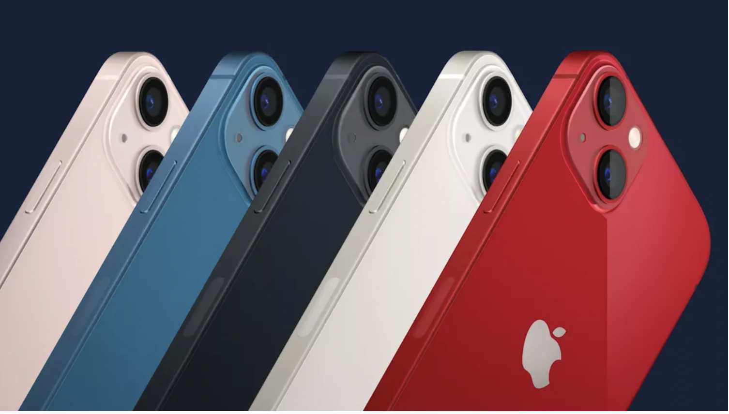

Suppose Apple wants to learn about the preferences of its current and potential future customers.

Apple is considering offering a software update to it’s iPhone 17 phones in the future that will allow them to serve as nodes on any household mesh wifi network, extending the range of wireless connectivity within a house. This is not a straightforward software update, and it may require some hardware updates as well. Apple is trying to learn how much consumers might be willing to pay for a software update that can be done remotely versus an update that would have to be done in the store. Suppose that Apple will end up offering only one of these options due to the fixed cost of setting up either store based or mobile software updates.

Use the following AI prompt verbatim: “"Design a complete survey plan for Apple to learn what customers would pay for this update: who to survey, how to reach them, how many people, and how to summarize the results for the VP. Be specific."

- What is the population of interest in this context vs. the survey frame that AI chose?

- What do you think about selection into / out of the sample and whether the AI-proposed strategy will address bias from selective non-response?

- Another member of your team suggests that a simple random sample may be problematic because the customers with the most at stake are the small fraction of customers who live far away from stores. Does the current AI prompt to do anything to address these concerns? What is one design fix you could propose to your AI agent?

- Are there any other prompts that you would send back before letting the AI field the survey?

